Week 3 Submission for marketing toolkit activity:
Submission
Jacques Benadie u25786947
https://www.rugbyworldcup.com/en/news/1001962/win-world-rugby-u20-championship-2025-title#:~:text=South%20Africa%20ended%20a%2013-year%20wait%20for%20a,in%20the%20Italian%20city%20of%20Rovigo%20on%20Saturday.
South Africa ended a 13-year wait for a second World Rugby U20 Championship title after beating New Zealand 23-15 in the final of the 2025 edition in the Italian city of Rovigo on Saturday. It was the first meeting of the two nations in a final since the Junior Springboks' class of 2012, featuring the likes of future Rugby World Cup winners Handre Pollard, Steven Kitshoff and Pieter-Steph du Toit, ran out 22-16 winners in Cape Town.
- Twitter Post:
Jacques Benadie (@JacquesBen36642) posted at 7:22 pm on Sun, Jul 20, 2025:
❕️Exciting news for South Africas under 20 squad. Winning their second world championship trophy for their country. As they beat the baby all black 23-15 in an amazing performance from both teams. #BabyBoks #under20champions #SAvsAllblacks #stongertogether
https://x.com/JacquesBen36642/status/1946983992978297047?t=NitlkAyIIFIQZgt5gJ0Lzg&s=03

- Sports Event Summary (for radio news bulletin):

South Africa’s under 20s vs New Zealand’s under 20s played against each other on Saturday 19 July 2025 in the Italian city of Rovigo. They played a thrilling final game for the world championship under20 trophy a spectacular performance from both sides with an end score of 23-15 for the South African boys. Another outstanding performance from the scrumhalf of South Africa Hassiem Pead, and the flanker that everybody is talking about to be the next Siya Kolisi , Bathobele Hlekani. He is a monster on the field this Saturday he struggled a bit with is handling but he makes up for that in his work rate. An outstanding performance from the All blacks flanker aswell Caleb Woodley and the inside center Jack Wiseman who had South Africa’s defense on their toes the entire game. South Africa opened up with a try in the 2nd minute of the game by Xola Nyali and the conversion from Vusi Simphiwe Moyo. The All blacks bounced back with a try in the 15th minute by Jayden Sa, unfortunately it was not converted. Vusi then added 3 points for the young South Africans in the 21st minute. Sika Pole from the New Zealand side the got shown a red card for fowl play just after South Africa conceded. Vusi then later in the game went for a drop goal that was unsuccessful. The referee went back to his pocket to award South Africa with a yellow card in the 31st minute awarded to Albie Bester the South African inside center. Vusi then converted the last points of the half from the kicking tee adding another 3 for the South African side. Halftime score was 13-5 to the baby Boks.
The second half started of with a penalty from Rico Simpson for 3 points to the u/20 All blacks, Vusi then contributed once again with a penalty conversion putting the New Zealand side having to score twice to take the game from the Boks. Another card was given to New Zealand when Xavier Treacy got a yellow card. South Africa then sealed the game with a brilliant chip kick from Pead to Mentoe to extend the lead to 23-8. New Zealand didn’t lie down and take it and scored a try in the 78th minute not giving up and a conversion from Will Cole adding the score to 23-15, but it was a little to late for the Under 20 New Zealand side when South Africa gained possession of the ball with 10 seconds left to play and winning the under 20 World Championship.
Now we have to wait another year to see which country will be on top for the 2026 U20 World Championship that is to be held in Georgia.

- Infographic (Comparing two sports teams' scores and progress in 2023):
Title of Infographic (insert here)

South Africa win their second under20 World Championship against their fierce rivals the under20 New Zealand side. It was a thrilling event with both teams giving their all and scoring 2 tries. South Africa set the standards in the game by scoring in the first 5 minutes of the game. Although New Zealand did not like that and scored in quick succession setting the score to 7-5 within the first 20 minutes of this exciting rugby match. In the end South Africa was just more clinical in using their opportunity with ball in hand and was crowned the World under20 Champions for 2025.
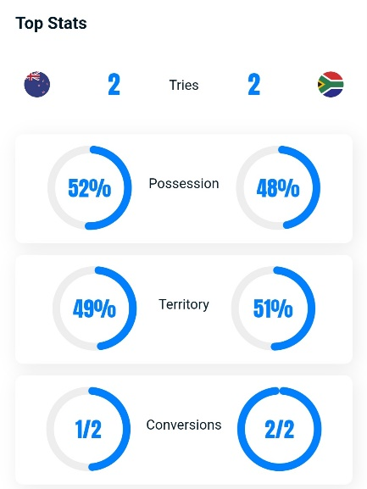
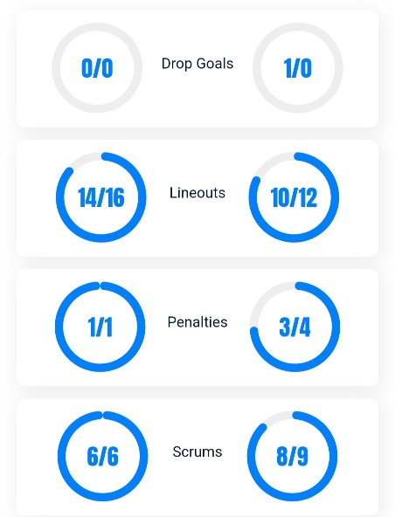
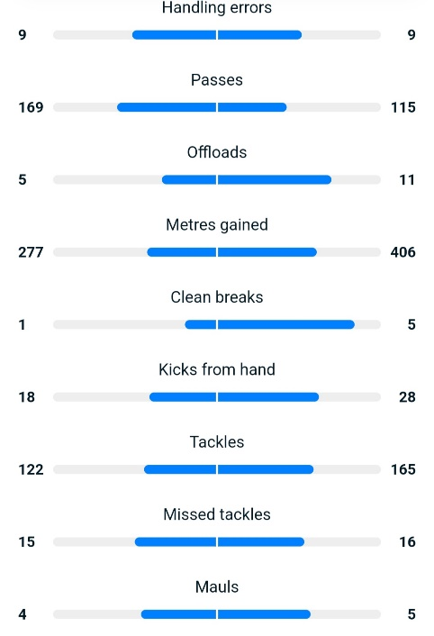

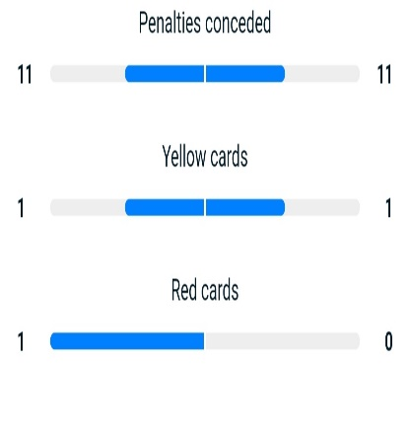

South Africa had the overhand in territory and that just build the pressure up for the New Zealand side. The New Zealand side had most of the possession in the game but they where not clinical enough to add points when they had the chance. The red card New Zealand got did not help with their chances of defeating this South African side, they put themselves on the backfoot the entire game by not gaining any forward momentum when they had the ball. South Africa’s defense was just to much for the All black side.

